

Year 5 | RE | Autumn 2 | Christian and Islam: Art and Music
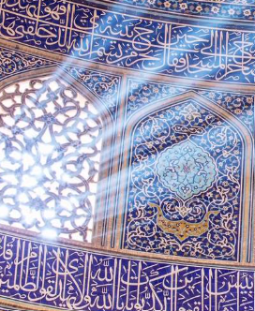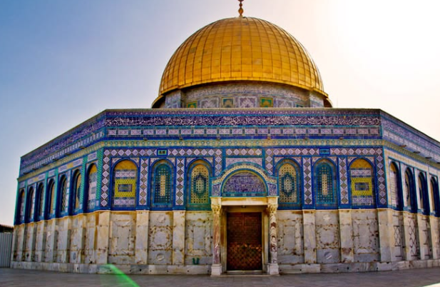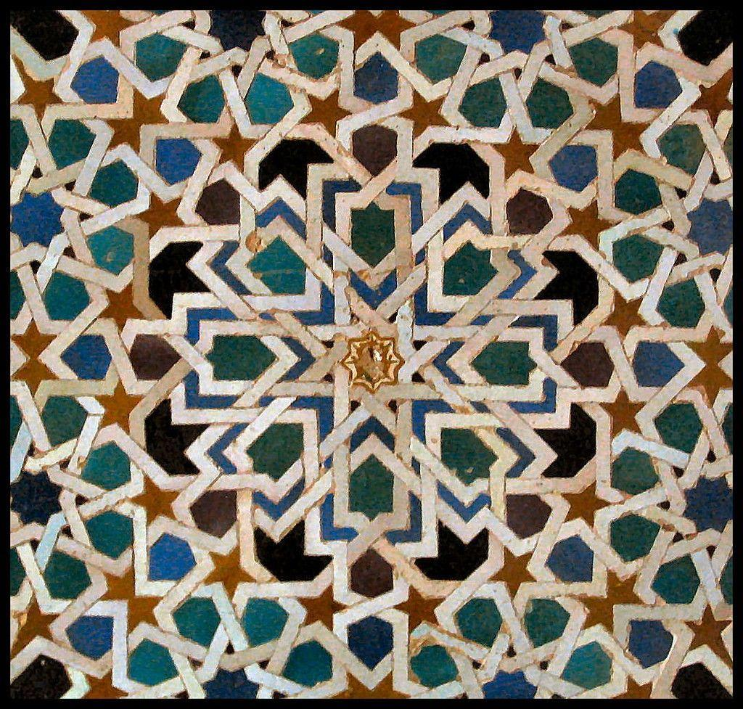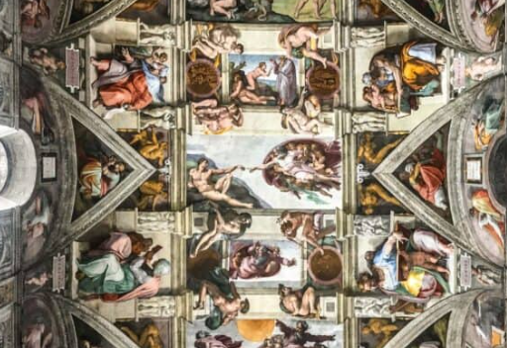
Vocabulary
Aniconism: avoiding images of God or holy figures in religious art and worship.
Architecture: the design and style of buildings.
Church: a Christian place of worship.
Expression: showing thoughts, feelings or beliefs through words, actions or art.
Hadith: a report about the words, actions or teachings of the Prophet Muhammad.
Hymn: a religious song used to praise or worship God.
Iconoclasm; the rejection or destruction of religious images because people believe they should not be used.
Mosque: a Muslim place of worship.
Prophet: a person believed to share messages from God.
Symbolic: using an object, image or sign to represent an idea or belief
We will be:
- Showing an awareness that talking about religion and belief can be complex.

- Explaining how beliefs impact on and influence individual lives, communities and society, and how individuals, communities and society can also shape beliefs.

- Describing ways in which beliefs shape the way Christians/Muslims view the world in which they live and how they view others.

Key Learning
Role of music in worship in the history of the Christian Church.
How art has been used in Christianity to reflect key events and facilitate worship.
Key teachings from the Quran, the Hadith and important Muslim teachers (Al-Ghazali) in regard to the use of music and art.
Response to instances of Aniconism and Iconoclasm by Muslims and Christians in history.

