
Year 5 | History| Autumn 2 | The Great War: WWI
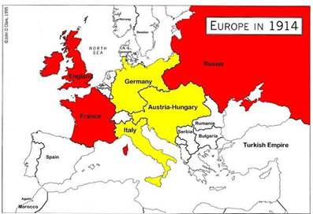
Vocabulary
The Great War - the First World War, which lasted from 1914 to 1918.
British Empire - Britain and the countries and territories it ruled around the world.
Allied forces - The countries that fought together against Germany and its allies during WW1, including Britain and France.
Front line - The area where opposing armies were fighting each other.
Propaganda - Information, posters or messages used to influence people's thoughts and encourage them to support a cause, such as joining the army.
Telegram- a message sent over long distances using electrical signals. During WW1, telegrams were used to send important news quickly.
Triple Alliance - an agreement between Germany, Austria-Hungary and Italy before WW1. Italy later joined the other side.
Triple Entente - an agreement between Britain, France and Russia before WW1.
No Man's Land - the dangerous area of land between the trenches of opposing armies, where soldiers could be attacked.
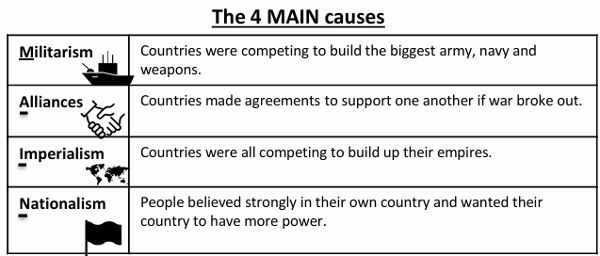
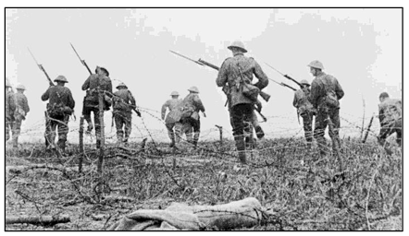
Timeline

