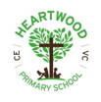
Year 5 | History| Autumn 1 | Ancient Egyptians
Timelines
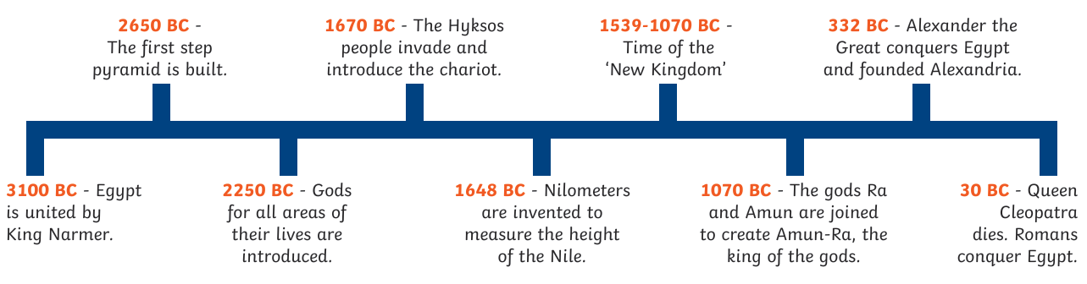
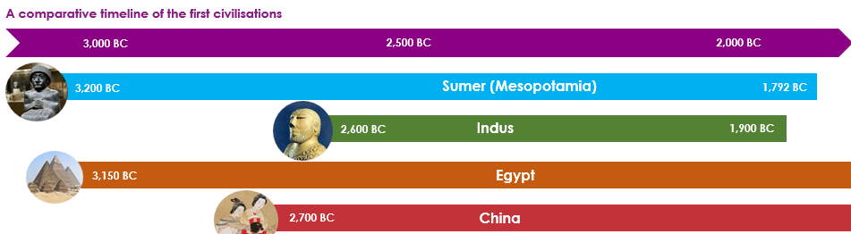
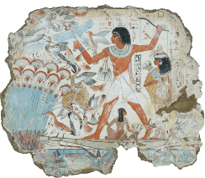
Vocabulary
Ancient | The term to describe history before 500AD
Artefact | An object made by human beings
Ankh | Symbol of life which only gods and kings carried
Civilisation | Way of life of a group of people
Embalming | Preserving the dead body using chemicals salts and oils
Excavate | To dig in the ground to discover old buildings or objects
Flax | Plant that can be made into cloth
Hieroglyphics | Symbols used by Ancient Egyptians in their writing
Mummification | A way of preserving a body after death
Natron salt | Absorbs water used to dry the body before it was wrapped in bandages
Papyrus | Paper made from the stems of the papyrus plant
Pharaoh | Ruler of Ancient Egypt who people thought came from the sun-god Ra
Pyramid | Stone structure built to house dead bodies of their kings
Sarcophagus | Massive stone painted outer coffin in which a mummy was stored
Scribe | Person whose job it was to read, write and keep records
Rosetta Stone | An important clue that helped researchers read hieroglyphics
Sphinx | Sculpture with lion’s body and head of the ruler built to guard the  pharaoh in the afterlife

Key Learning
Egypt was ruled by Pharaohs who were seen more like a god than just a person. Tutankhamun is one of the most famous Pharaohs whose tomb was only discovered just over 100 years ago by Howard Carter (from Swaffham!).
Ancient Egyptians worshipped hundreds of gods, many represented by animals.
Daily life in Egypt was influenced by the river Nile which flooded every year and was essential for growing crops.
Egyptians thought that people who died went to a new world. They helped the person who had died enter this new world in the best possible way, preparing their body and providing items for their next life.
Much of what we know about Ancient Egypt comes from the Rosetta stone, discovered only 200 years ago.
Life and Death: gods and goddesses


