

Year 5 | RE | Autumn 1 | Humanism
Key Learning
Look at definitions of belief: Atheist, Agnostic, Theist.

Explore Pascal’s Wager as an example of a philosophical explanation.

Consider Humanism as an example of a philosophical stance.

Develop our Philosophy skills:

- How to explain, using a range of reasons, whether a position or argument is coherent and logical.
- Use philosophical vocabulary e.g. knowing, truth, proof, reality, fact, opinion.
- How to form a coherent argument to support or oppose the existence of God.

We will be:
Exploring Christian faith, what the faith rests on and ideas around faith in the unseen and unknown: Christians put their trust in…

Looking at the Humanist viewpoint: observation, experimentation and the testing of theories against evidence.

We will compare and consider, can a Christian be a scientist?
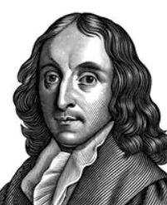
Vocabulary
Humanist: Someone who believes people can live good and meaningful lives using reason, kindness and human values, without needing to believe in God.
Christian: A person who follows the teachings of Jesus Christ and believes in God.
Atheist: Someone who does not believe in God or gods.
Agnostic: Someone who thinks we cannot know for certain whether God or gods exist.
Faith: Trust or belief in something, especially in God or religious teachings.
Theist: Someone who believes that God or gods exist.
Reason: Using thinking and logic to decide what you believe or what is true.
Evidence Information, facts or observations that help us decide whether something is true or not.

