
Year 5 | Science | Autumn 1 | Materials
Vocabulary
Soluble: something that can dissolve in a liquid, like sugar in water.
Reversible: a change that can be undone.
Irreversible: a change that cannot be undone.
Independent variable: the one thing you choose to change in an experiment.
Dependent variable: what you measure or observe to see what happens because of the change.
Hypothesis: a sensible idea about what you think will happen.
Transparent: something you can see clearly through, like a clean window.
Conductor: a material that lets heat or electricity travel through it easily.
Dissolve: when something mixes into a liquid until you can't see it anymore.
Solution: the mixture that is made when something dissolves in a liquid.
Evaporate: when a liquid changes into a gas and disappears into the air.
Insulator: a material that does not let heat or electricity travel through it easily.
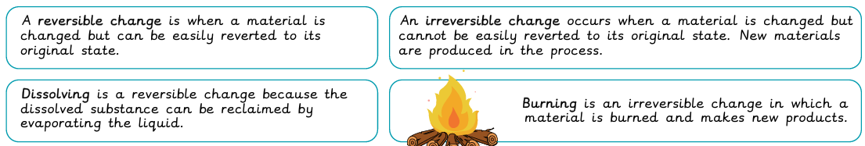
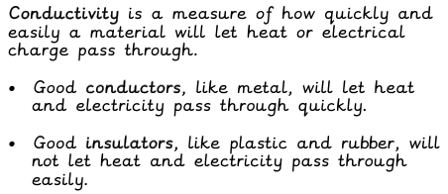
Key Learning


