

Year 6 | Science | Summer 1 | Evolution and Inheritance
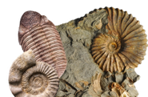
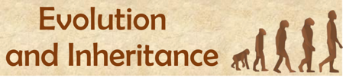
Key Learning
Fossils - A fossil is any preserved remains, impression, or trace of any once-living thing from a past geological age. Examples include bones, shells, exoskeletons, stone imprints of animals. It is from fossils that scientists can work out adaptations in living things.
Plant and Animal adaptations - Adaptation of plants and animals to their changing environments through natural selection is a process over time. The characteristics passed on are called the ‘adaptive traits’.
Inheritance - We are all human and share some features, but there is variation between us. This is called genetic diversity. The majority of living things are the result of sexual reproduction, so they have two parents. When parents produce an offspring, their characteristics are mixed randomly to form offspring with features from both parents. All living things produce offspring of the same kind, but the offspring are rarely identical to the parents. The inherited characteristics can combine in different ways, which is the reason why siblings inherit the same characteristics but are not identical to each other.

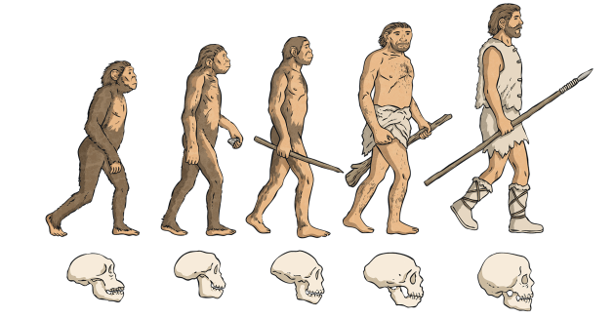
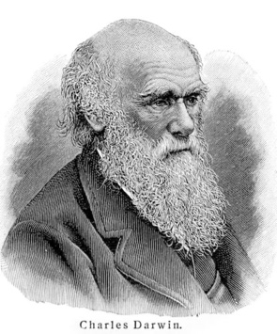
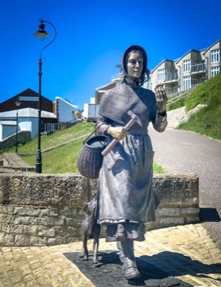
Charles Darwin
Darwin was an English scientist who studied nature. He is known for his theory of evolution by
natural selection.
In 1831, Darwin was invited to become a naturalist for Captain Fitzroy on the survey ship the HMS Beagle. They visited the Galapagos Islands where Darwin made his discovery about finches. In his theory of ‘natural selection’, he concluded that species with traits most suited to the environment are more likely to survive and have healthy offspring which will inherit the same or similar traits.

Mary Anning
Mary Anning was a pioneering palaeontologist and fossil collector. She was born in 1799 in Lyme Regis, in the southwest English county of Dorset. Lyme Regis is part of what is called the Jurassic Coast, and discoveries are still being made to this day. Her most famous discoveries include a plesiosaur (giant sea reptile), a flying reptile and a prehistoric fish. Sadly, it was not revealed who had discovered them at the time showing the disregard for women in science at this time.

Vocabulary
Adaptation: something that helps a living thing survive.
Habitat: where a plant or animal lives.
Environment: everything around a living thing.
Species: a group of similar living things.
Dominant: a trait that is more likely to show.
Extinct: when all of a kind have died out.
Natural selection: when the best suited survive and have young.
Sexual reproduction: two parents make a baby.
Asexual reproduction: one parent makes a copy of itself.
Offspring: a baby or young.
Characteristics: features of a living thing.
Creation: the idea that a creator made living things.
Hominids: humans and early humans.
Fossils: remains of plants or animals from long ago.

