

Year 6 | RE | Spring 2 | Creation or Science
We will be:
- Identifying what type of text some Christians say Genesis 1 is, and its purpose.
- Taking account of the context, suggesting what Genesis 1 might mean, and comparing how Christians interpret it.
- Making clear connections between Genesis 1 and Christian belief about God as creator.
- Showing understanding of why many Christians find science and faith go together
- Identifying key ideas arising from the study of Genesis 1 and commenting on how far these are helpful or inspiring justifying their responses.

Key Learning
Genesis 1: The creation story from the biblical Book of Genesis describes how God created heaven and earth, plants, animals, and people; and later how the first people were cast out of the Garden of
Eden as punishment for eating from the 'tree of knowledge of
good and evil. ' In the beginning God created the heaven and
the earth…..

Cosmology is the study of the start of the Universe. The Big Bang Theory is a scientific model that describes how the universe began with a giant blast of matter and energy about 14 billion years ago.
As the new universe cooled, tiny particles combined to form the building blocks of atoms, or the basic building blocks of matter. Life evolved on Earth with humans and apes evolving from common ancestors.
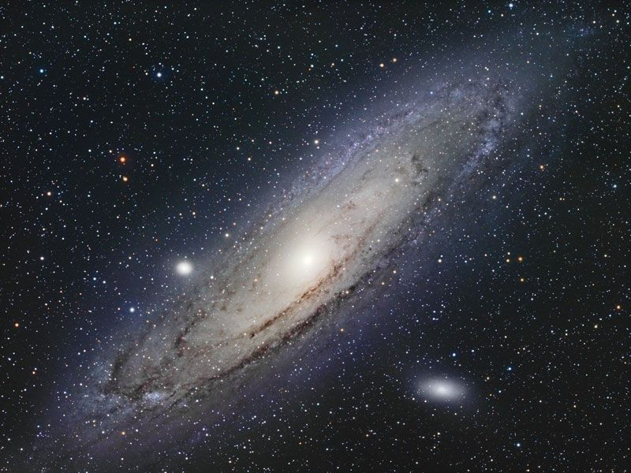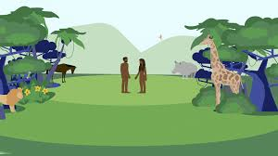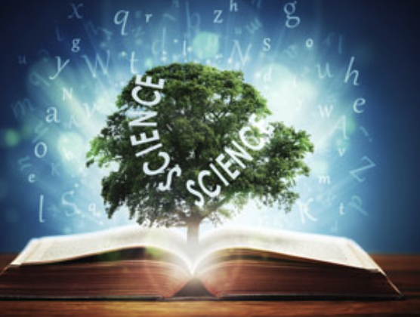
Vocabulary
Big Bang: The idea that the universe began from a very small, hot point and has been expanding ever since.
Theory: An explanation of something that is based on evidence and careful thinking.
Cosmology: The study of the universe and how it began and changes over time.
Creation theory: The belief that a god or higher power created the universe and everything in it.
Evidence: Facts or information that help to prove something is true.
Evolution: The process by which living things change slowly over a very long time.
Genesis: The first book of the Bible, which describes how God created the world.

