

Year 6 | Science | Spring 2 | Electricity

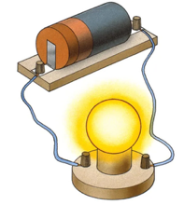
Key Learning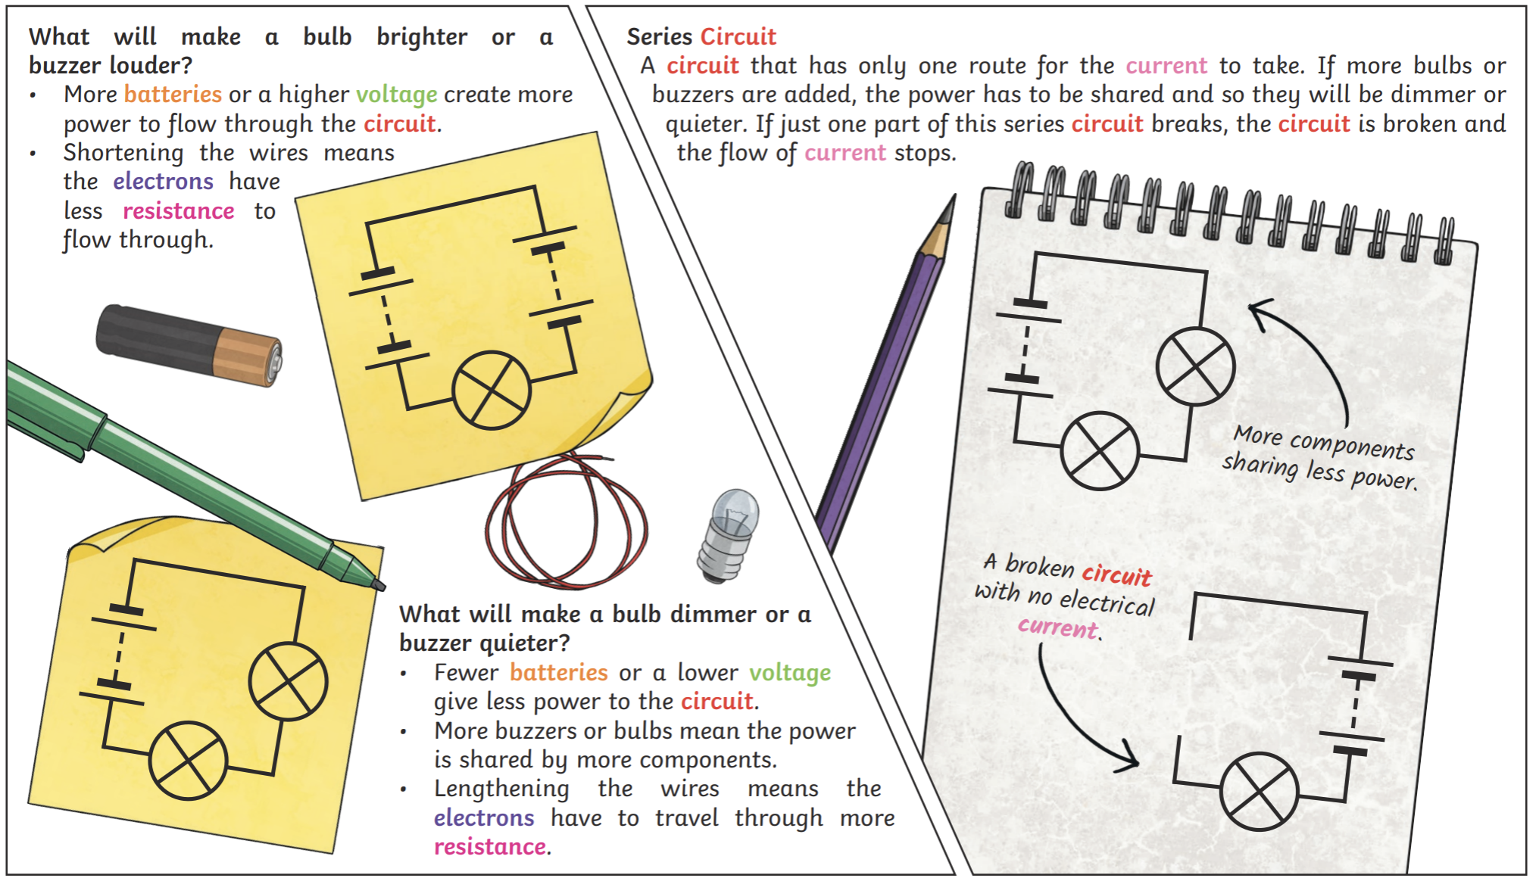
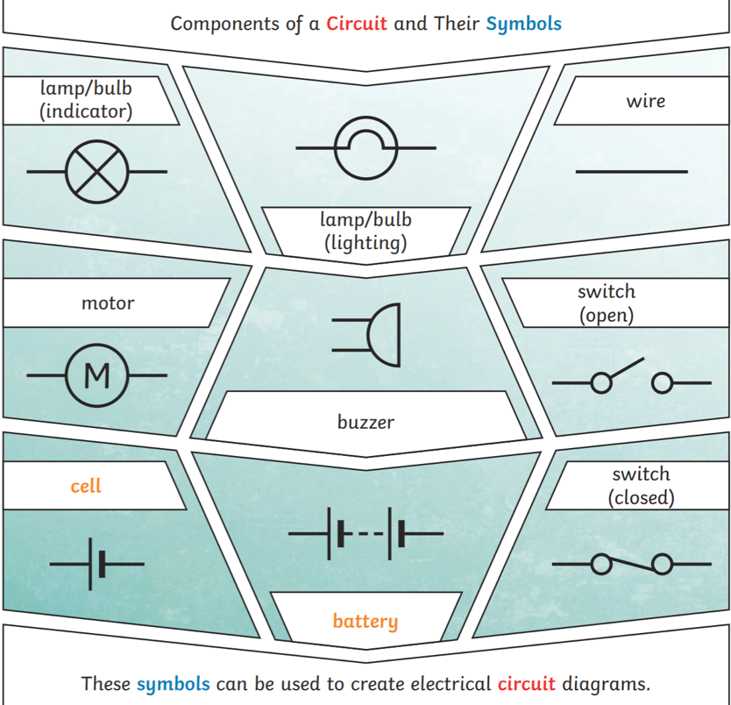

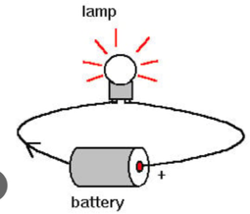

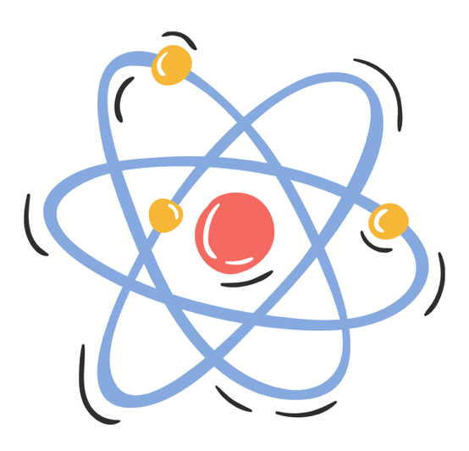

Circuit: A complete loop that allows electricity to flow.
Series: A circuit where components are connected one after another in a single loop.
Conductors: Materials that allow electricity to pass through them easily.
Insulators: Materials that do not allow electricity to pass through them easily.
Amps: A measure of how much electric current is flowing.
Volts: A measure of how much electrical energy pushes the current around a circuit.

Vocabulary
Cell: A single source of electrical energy that provides power to a circuit.
Battery: Two or more cells joined together to provide electrical energy.
Bulb: A lamp that lights up when electricity flows through it.
Switch: A device that opens or closes a circuit to turn electricity on or off.
Buzzer: A device that makes a sound when electricity flows through it.

