Life Skills in the Early Years at Heartwood.

At Heartwood we are passionate about nurturing and growing hearts and minds, today, tomorrow, and for life. A major part of this is through our Life Skills curriculum. We strive to provide a rich variety of experiences so that all pupils are able to flourish and discover their unique strengths and talents in a safe environment. In the Early Years Life Skills teaching happens mostly ‘in the moment’ during busy time when helping children to resolve conflicts, trying again, building confidence to try new things, and building resilience. However, we are mindful that not all children have the same experiences; therefore, we have developed the Early Years curriculum to ensure that all children have access to Life Skills sessions throughout their time in the Early Years to develop their knowledge and skills to keep themselves safe, happy, and well.

Please see below our long term plans for Mouse Class and Rabbit Class for this year, as well as some useful links and stories overleaf to share with your children.

Mouse Class
Autumn 1 | Autumn 2 | Spring 1 | Spring 2 | Summer 1 | Summer 2
Who is special to me? | How can I be a respectful friend? | Understanding feelings | How do I look after my body? | How can we look after each other and our world? | What is the same and different about us?

Rabbit Class
Autumn 1 | Autumn 2 | Spring 1 | Spring 2 | Summer 1 | Summer 2
My Feelings | Families and people who are for me  My body | Caring friendships  My relationships | Respectful relationships  My beliefs  Health and germ prevention | Online safety  My rights and responsibilities | Being safe  Asking form help

If you would like to know more about any of the topics covered please speak to myself or Mrs McMillen, our Life Skills lead.

Kind Regards
Mr Powley
Early Years Lead (maternity cover)

Useful links and stories:

Resource | About | QR code link
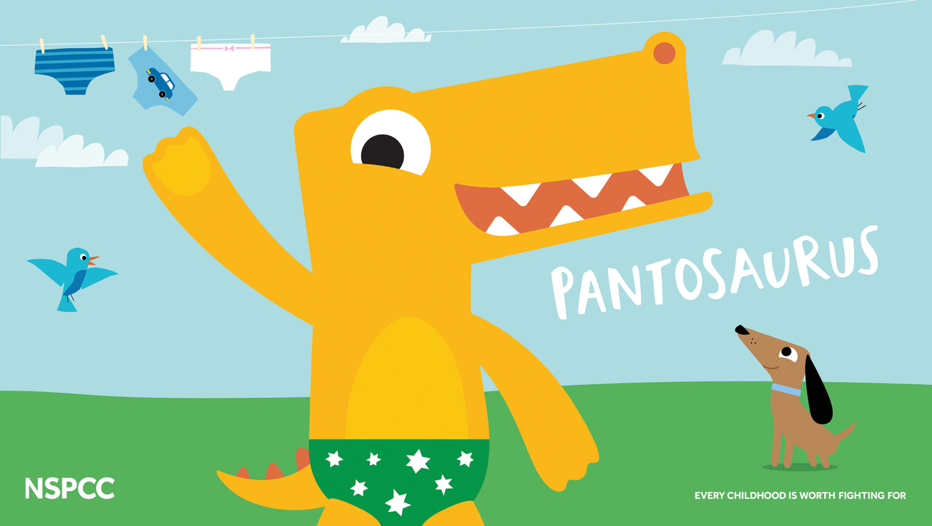 | Pantosaurus  Pantosaurus teaches children the ‘PANTS’ rule and how to keep themselves and other safe. | 
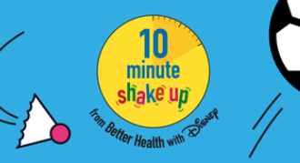 | NHS 10 minute shake up  Get the children moving with these fun games inspired by some of their favourite Disney characters.  These boredom-busting activities will help them reach the 60 active minutes they need every day | 
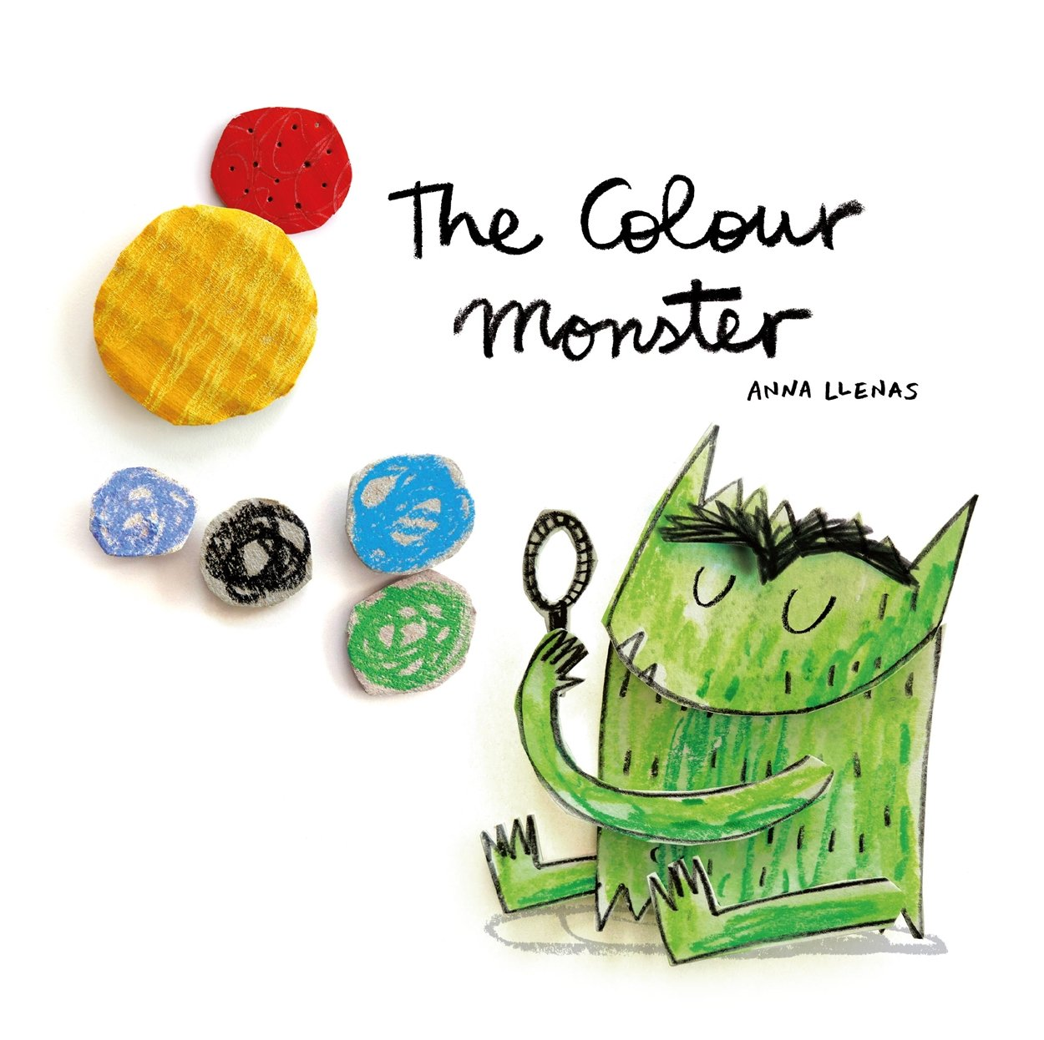 | The Colour Monster  This sensitive book encourages children to open up and discuss how they feel, even when their thoughts are confusing. | 
 | Smartie the Penguin  Join in with Mummy Penguin’s song and follow the adventures of Smartie the Penguin as he learns how to be safe on the internet. | 
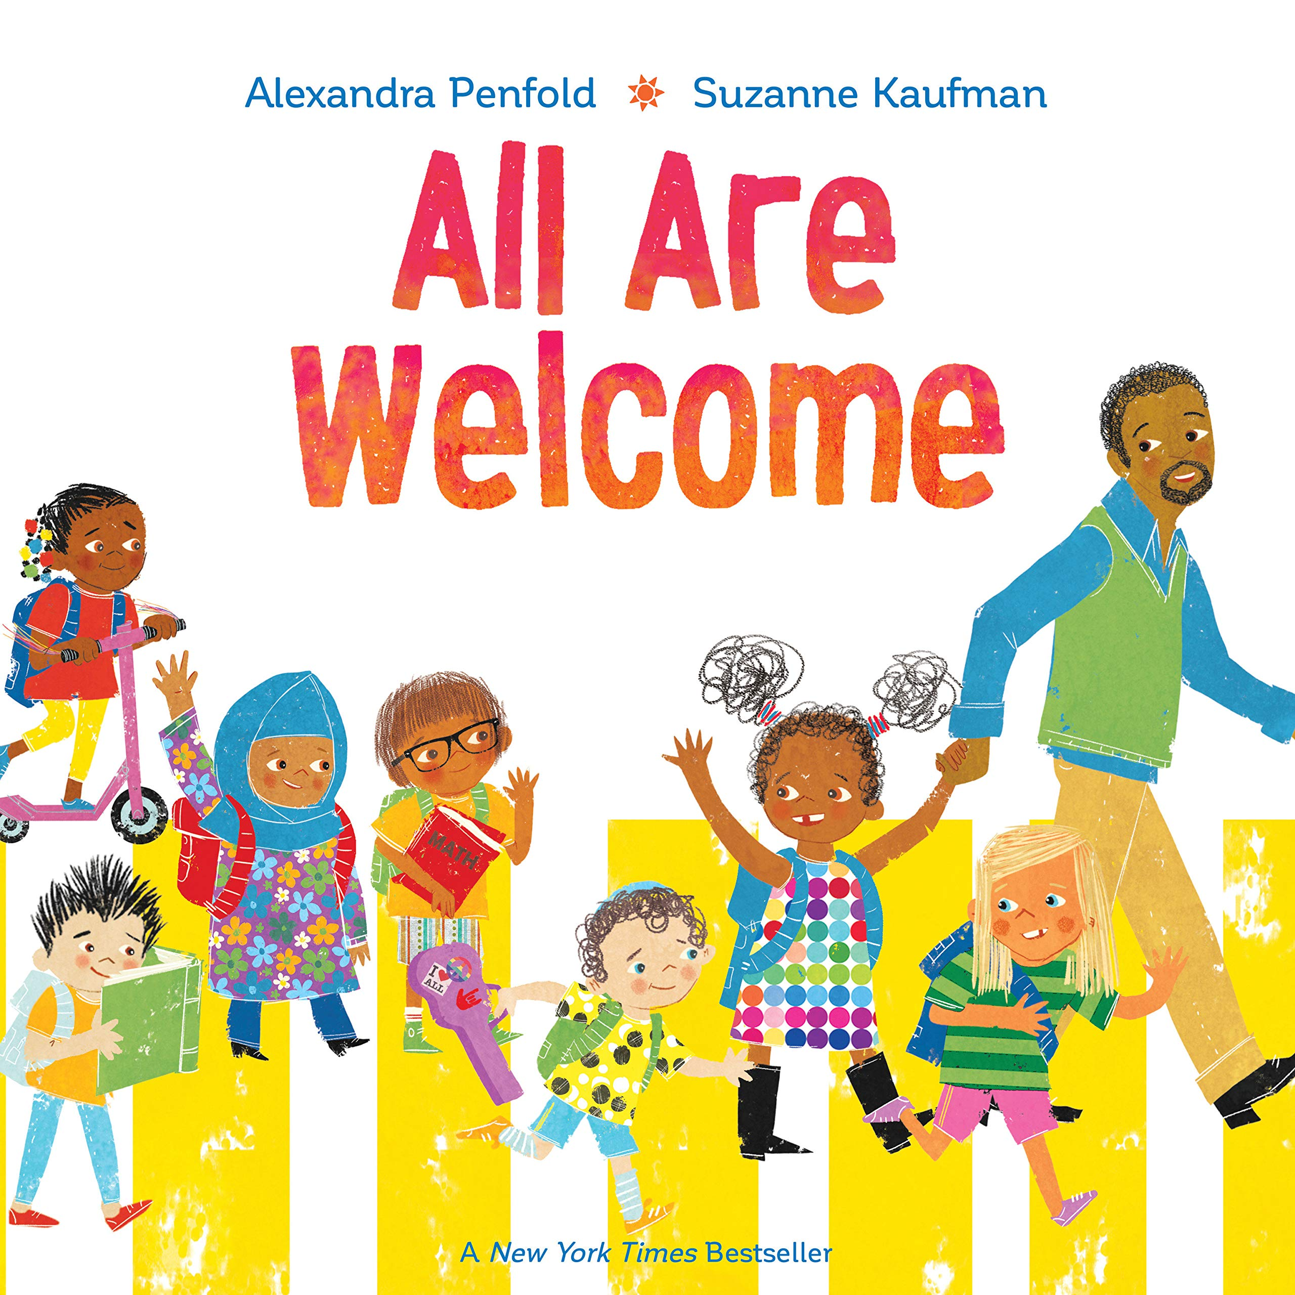 | All Are Welcome  A bright and uplifting celebration of cultural diversity and belonging, where all children are welcome in the classroom. | 

